Task 5

5. Passing Props to a Component

Tasks:

1. Create a Movie component that displays the title, year, and rating of a movie

using props.

**Movie.jsx**

import React from 'react'

export default function Movie(props) {

return (

<>

<h3>The title is {props.title}</h3>

<h3>The year is {props.year}</h3>

<h3>The rating is {props.rating}</h3>

</>

)

}

**Main.jsx**

import Movie from './Movie.jsx'

createRoot(document.getElementById('root')).render(

<StrictMode>

<Movie title="KGF" year="2018" rating="8.5"/>

</StrictMode>

)

**Output**

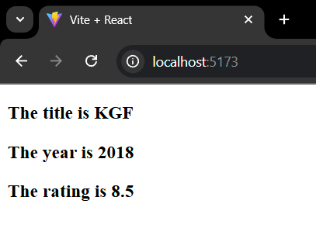

2. Update the Movie component to have a default prop for rating as “Not Rated”.

**Movie.jsx**

import React from 'react'

export default function Movie({ title, year, rating = "Not Rated" }) {

return (

<>

<h3>The title is {title}</h3>

<h3>The year is {year}</h3>

<h3>The rating is {rating}</h3>

</>

)

}

**Main.jsx**

import Movie from './Movie.jsx'

createRoot(document.getElementById('root')).render(

<StrictMode>

<Movie title="KGF" year="2018"/>

<Movie title="KGF2" year="2018" rating="8.5"/>

</StrictMode>

)

**Output**

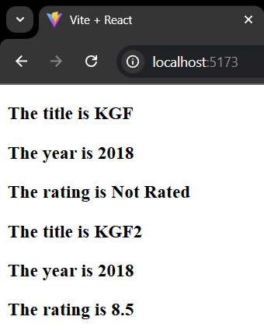

3. Design a Button component that takes in a label prop and displays the label on

the button.

**Main.jsx**

import Button from './Button.jsx'

createRoot(document.getElementById('root')).render(

<StrictMode>

<Button name="Click Me!"/>

<Button name="Submit" />

</StrictMode>

)

**Button.jsx**

import React from 'react'

export default function Button(props) {

return (

<>

<button>{props.name}</button>

</>

)

}

**Output**

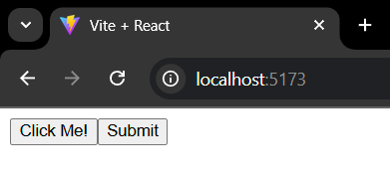

4. Make a UserProfile component and pass an object containing user details as

props and display them.

**Userprofile.jsx**

import React from 'react'

export default function UserProfile(props) {

return (

<>

<h3>Name: {props.name}</h3>

<h3>Age: {props.age}</h3>

<h3>Gender: {props.gender}</h3>

</>

)

}

**Main.jsx**

import UserProfile from './UserProfile.jsx'

createRoot(document.getElementById('root')).render(

<StrictMode>

<UserProfile name="Kavin" age="21" gender="male"/>

</StrictMode>

)

**Output**

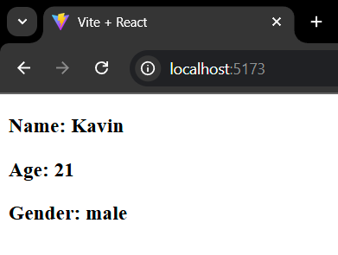

5. Develop a Modal component that accepts and displays a title and some

content passed as props.

**Modal.jsx**

import React from 'react'

export default function Modal(props) {

return (

<>

<h2>{props.title}</h2>

<p>{props.content}</p>

</>

)

}

**Main.jsx**

import Modal from './Modal.jsx'

createRoot(document.getElementById('root')).render(

<StrictMode>

<Modal title="React" content="React is a JavaScript library primarily used for building user interfaces (UIs) for web applications"/>

</StrictMode>

)

**Output**

